# 5. DynamicModel

## 5.1 Sequence Diagrams

### 5.1.1 The game update loop Sequence Diagram

This diagram shows an overview of the game update loop, which repeatedly causes the game world and game objects to update based on changes in the game state.

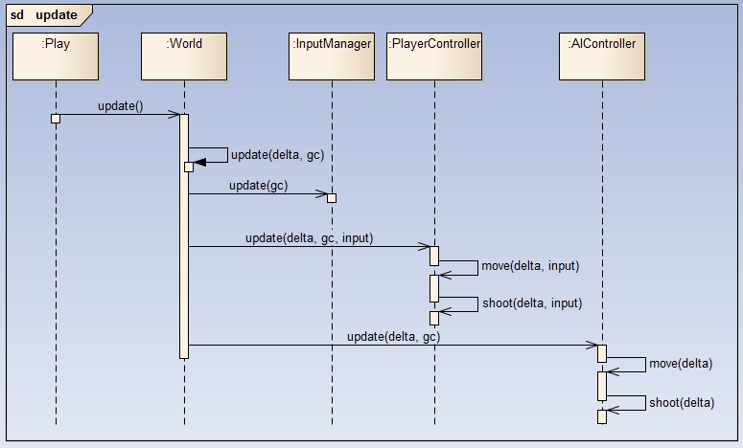

### 5.1.2 The game render loop Sequence Diagram

This diagram shows an overview of the game update loop, which repeatedly causes the game objects to render.

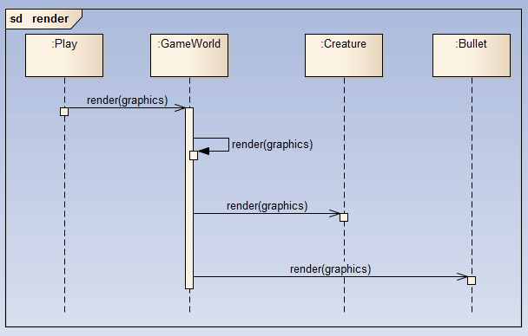

### 5.1.3 ­­Creature death Sequence Diagram

This diagram shows the interactions between a creature and the game world that occur when a creature dies in the game.

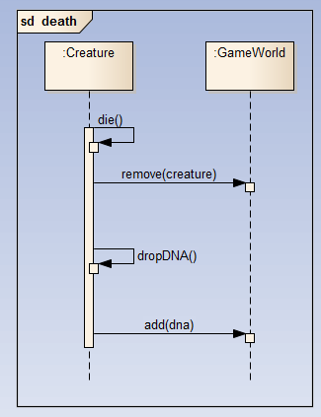

### 5.1.4 pickup dna sequence diagram

This diagram shows the process of a creature picking up a piece of DNA, causing a new creature to spawn, and be placed in control of the player.

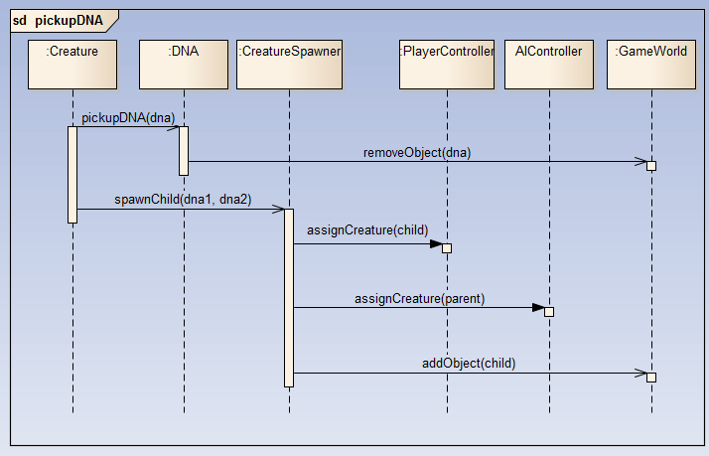

## 5.2. ACTIVITY Diagrams

### 5.2.1. Main menu activity diagram

This diagram shows the various possible flows that can occur when a user interacts with the main menu options.

### 5.2.2. gameplay activity diagram

This diagram shows the various possible flows that can occur while a user is playing the game.